Databases Final report
Albi Tavakoli
ID:3798716
This project presents a vinyl shop database application developed using SQL and Java with JDBC. The system was designed to manage artists, vinyl records, and customer orders. The implementation demonstrates core database operations including table creation, data insertion, querying, updating, and deletion. A menu-driven Java application was developed to allow user interaction with the database. The project highlights how relational database design and Java integration can be used to build functional data management system.
Databases are essential for storing and managing structured data efficiently. In this project, a vinyl shop database system was developed to simulate how a real-world music store manages its inventory and sales.
The goal of this project was to:
- design a relational database using SQL
- implement the database using SQLite
- connect the database to Java using JDBC
- create a menu-driven application to interact with the data
This project demonstrates both database design principles and basic software development using Java.
The system is a Vinyl Shop Database Application that allows a user (store owner) to manage:
- artists
- vinyl records
- customer orders
The database consists of 3 tables, Artist, Vinyl and costumer order. The relationship between them is that one artist can have multiple vinyls and one vinyl and appear in many customer orders.
The requirements I satisfied are:
I implemented a database instance (vinylshop.db) and implemented some SQL operations. I designed a menu-driven program and created functions for each operation. Connected the database to java using JDBC and designed a class structure for the program.
This project provided practical experience in both database design and Java programming. I learned how to create relational tables, define primary and foreign keys, and use SQL for data manipulation. I also learned how to connect a Java application to a database using JDBC and how to execute SQL queries from within Java.
One of the key challenges was debugging issues related to primary key constraints and understanding how joins affect query results. For example, using an inner join initially caused some data not to appear, which was resolved by understanding the relationship between tables.
Overall, this project improved my understanding of how databases and applications work together in real-world systems.

Java source code

import java.sql.Connection;
import java.sql.DriverManager;
import java.sql.ResultSet;
import java.sql.SQLException;
import java.sql.Statement;
import java.util.Scanner;

public class VinylShopDB {

static final String URL = "jdbc:sqlite:vinylshop.db";

public static void main(String[] args) {
Scanner input = new Scanner(System.in);
int choice;

do {
System.out.println("\n--- Vinyl Shop Database Menu ---");
System.out.println("1. Create tables");
System.out.println("2. Insert sample data");
System.out.println("3. View artists");
System.out.println("4. View vinyl records");
System.out.println("5. View customer orders");
System.out.println("6. Update vinyl stock");
System.out.println("7. Delete customer order");
System.out.println("8. Add new vinyl");
System.out.println("9. Search vinyl by title");
System.out.println("10. Place customer order");
System.out.println("11. Exit");
System.out.print("Enter your choice: ");

choice = input.nextInt();
input.nextLine();

switch (choice) {
case 1:
createTables();
break;
case 2:
insertSampleData();
break;
case 3:
viewArtists();
break;
case 4:
viewVinyl();
break;
case 5:
viewOrders();
break;
case 6:
updateVinylStock(input);
break;
case 7:
deleteOrder(input);
break;
case 8:
addNewVinyl(input);
break;
case 9:
searchVinylByTitle(input);
break;
case 10:
placeCustomerOrder(input);
break;
case 11:
System.out.println("Exiting program.");
break;
default:
System.out.println("Invalid choice.");
}

} while (choice != 11);

input.close();
}

public static Connection connect() throws SQLException {
return DriverManager.getConnection(URL);
}

public static void createTables() {
try (Connection conn = connect(); Statement stmt = conn.createStatement()) {

String artistTable = "CREATE TABLE IF NOT EXISTS Artist (" +
"artist_id INT PRIMARY KEY, " +
"artist_name VARCHAR(100) NOT NULL, " +
"country VARCHAR(50))";

String vinylTable = "CREATE TABLE IF NOT EXISTS Vinyl (" +
"vinyl_id INT PRIMARY KEY, " +
"title VARCHAR(100) NOT NULL, " +
"genre VARCHAR(50), " +
"release_year INT, " +
"price DECIMAL(8,2), " +
"stock_quantity INT, " +
"artist_id INT, " +
"FOREIGN KEY (artist_id) REFERENCES Artist(artist_id))";

String orderTable = "CREATE TABLE IF NOT EXISTS CustomerOrder (" +
"order_id INT PRIMARY KEY, " +
"customer_name VARCHAR(100), " +
"order_date TEXT, " +
"quantity INT, " +
"total_amount DECIMAL(8,2), " +
"vinyl_id INT, " +
"FOREIGN KEY (vinyl_id) REFERENCES Vinyl(vinyl_id))";

stmt.execute(artistTable);
stmt.execute(vinylTable);
stmt.execute(orderTable);

System.out.println("Tables created successfully.");

} catch (SQLException e) {
System.out.println("Error creating tables: " + e.getMessage());
}
}

public static void insertSampleData() {
try (Connection conn = connect(); Statement stmt = conn.createStatement()) {

stmt.executeUpdate("INSERT OR IGNORE INTO Artist VALUES (1, 'The Weeknd', 'Canada')");
stmt.executeUpdate("INSERT OR IGNORE INTO Artist VALUES (2, 'Lana Del Rey', 'USA')");
stmt.executeUpdate("INSERT OR IGNORE INTO Artist VALUES (3, 'Fleetwood Mac', 'UK')");

stmt.executeUpdate("INSERT INTO Vinyl VALUES (101, 'After Hours', 'R&B', 2020, 34.99, 5, 1)");
stmt.executeUpdate("INSERT INTO Vinyl VALUES (102, 'Born To Die', 'Alternative', 2012, 29.99, 3, 2)");

stmt.executeUpdate("INSERT INTO CustomerOrder VALUES (1001, 'Alice', '2026-04-06', 1, 34.99, 101)");
stmt.executeUpdate("INSERT INTO CustomerOrder VALUES (1002, 'Bob', '2026-04-06', 2, 59.98, 102)");

System.out.println("Sample data inserted.");

} catch (SQLException e) {
System.out.println("Error inserting data: " + e.getMessage());
}
}

public static void viewArtists() {
try (Connection conn = connect(); Statement stmt = conn.createStatement()) {
ResultSet rs = stmt.executeQuery("SELECT * FROM Artist");

System.out.println("\nArtists:");
while (rs.next()) {
System.out.println(rs.getInt("artist_id") + " - " +
rs.getString("artist_name") + " - " +
rs.getString("country"));
}

} catch (SQLException e) {
System.out.println("Error viewing artists: " + e.getMessage());
}
}

public static void viewVinyl() {
try (Connection conn = connect(); Statement stmt = conn.createStatement()) {
ResultSet rs = stmt.executeQuery(
"SELECT v.vinyl_id, v.title, v.genre, v.release_year, v.price, v.stock_quantity, a.artist_name " +
"FROM Vinyl v LEFT JOIN Artist a ON v.artist_id = a.artist_id");

System.out.println("\nVinyl Records:");
while (rs.next()) {
System.out.println(rs.getInt("vinyl_id") + " - " +
rs.getString("title") + " - " +
rs.getString("genre") + " - " +
rs.getInt("release_year") + " - $" +
rs.getDouble("price") + " - Stock: " +
rs.getInt("stock_quantity") + " - Artist: " +
rs.getString("artist_name"));
}

} catch (SQLException e) {
System.out.println("Error viewing vinyl: " + e.getMessage());
}
}

public static void viewOrders() {
try (Connection conn = connect(); Statement stmt = conn.createStatement()) {
ResultSet rs = stmt.executeQuery(
"SELECT o.order_id, o.customer_name, v.title, o.quantity, o.total_amount, o.order_date " +
"FROM CustomerOrder o JOIN Vinyl v ON o.vinyl_id = v.vinyl_id");

System.out.println("\nCustomer Orders:");
while (rs.next()) {
System.out.println("Order ID: " + rs.getInt("order_id") +
", Customer: " + rs.getString("customer_name") +
", Vinyl: " + rs.getString("title") +
", Quantity: " + rs.getInt("quantity") +
", Total: $" + rs.getDouble("total_amount") +
", Date: " + rs.getString("order_date"));
}

} catch (SQLException e) {
System.out.println("Error viewing orders: " + e.getMessage());
}
}

public static void updateVinylStock(Scanner input) {
System.out.print("Enter vinyl ID: ");
int vinylId = input.nextInt();

System.out.print("Enter new stock quantity: ");
int newStock = input.nextInt();
input.nextLine();

try (Connection conn = connect(); Statement stmt = conn.createStatement()) {
String sql = "UPDATE Vinyl SET stock_quantity = " + newStock +
" WHERE vinyl_id = " + vinylId;
int rows = stmt.executeUpdate(sql);

if (rows > 0) {
System.out.println("Vinyl stock updated.");
} else {
System.out.println("Vinyl not found.");
}

} catch (SQLException e) {
System.out.println("Error updating stock: " + e.getMessage());
}
}

public static void deleteOrder(Scanner input) {
System.out.print("Enter order ID to delete: ");
int orderId = input.nextInt();
input.nextLine();

try (Connection conn = connect(); Statement stmt = conn.createStatement()) {
String sql = "DELETE FROM CustomerOrder WHERE order_id = " + orderId;
int rows = stmt.executeUpdate(sql);

if (rows > 0) {
System.out.println("Order deleted.");
} else {
System.out.println("Order not found.");
}

} catch (SQLException e) {
System.out.println("Error deleting order: " + e.getMessage());
}
}

public static void addNewVinyl(Scanner input) {
System.out.print("Enter vinyl ID: ");
int vinylId = input.nextInt();
input.nextLine();

System.out.print("Enter title: ");
String title = input.nextLine();

System.out.print("Enter genre: ");
String genre = input.nextLine();

System.out.print("Enter release year: ");
int releaseYear = input.nextInt();

System.out.print("Enter price: ");
double price = input.nextDouble();

System.out.print("Enter stock quantity: ");
int stockQuantity = input.nextInt();

System.out.print("Enter artist ID: ");
int artistId = input.nextInt();
input.nextLine();

try (Connection conn = connect(); Statement stmt = conn.createStatement()) {
String sql = "INSERT INTO Vinyl VALUES (" +
vinylId + ", '" +
title + "', '" +
genre + "', " +
releaseYear + ", " +
price + ", " +
stockQuantity + ", " +
artistId + ")";

stmt.executeUpdate(sql);
System.out.println("New vinyl added successfully.");

} catch (SQLException e) {
System.out.println("Error adding vinyl: " + e.getMessage());
}
}

public static void searchVinylByTitle(Scanner input) {
System.out.print("Enter vinyl title to search: ");
String title = input.nextLine();

try (Connection conn = connect(); Statement stmt = conn.createStatement()) {
String sql = "SELECT v.vinyl_id, v.title, v.genre, v.release_year, v.price, v.stock_quantity, a.artist_name " +
"FROM Vinyl v JOIN Artist a ON v.artist_id = a.artist_id " +
"WHERE v.title LIKE '%" + title + "%'";

ResultSet rs = stmt.executeQuery(sql);

boolean found = false;
while (rs.next()) {
found = true;
System.out.println(rs.getInt("vinyl_id") + " - " +
rs.getString("title") + " - " +
rs.getString("genre") + " - " +
rs.getInt("release_year") + " - $" +
rs.getDouble("price") + " - Stock: " +
rs.getInt("stock_quantity") + " - Artist: " +
rs.getString("artist_name"));
}

if (!found) {
System.out.println("No vinyl found with that title.");
}

} catch (SQLException e) {
System.out.println("Error searching vinyl: " + e.getMessage());
}
}

public static void placeCustomerOrder(Scanner input) {
System.out.print("Enter order ID: ");
int orderId = input.nextInt();
input.nextLine();

System.out.print("Enter customer name: ");
String customerName = input.nextLine();

System.out.print("Enter order date (YYYY-MM-DD): ");
String orderDate = input.nextLine();

System.out.print("Enter vinyl ID: ");
int vinylId = input.nextInt();

System.out.print("Enter quantity: ");
int quantity = input.nextInt();
input.nextLine();

try (Connection conn = connect(); Statement stmt = conn.createStatement()) {

String getVinylSql = "SELECT price, stock_quantity FROM Vinyl WHERE vinyl_id = " + vinylId;
ResultSet rs = stmt.executeQuery(getVinylSql);

if (rs.next()) {
double price = rs.getDouble("price");
int stock = rs.getInt("stock_quantity");

if (quantity > stock) {
System.out.println("Not enough stock available.");
return;
}

double totalAmount = price * quantity;

String insertOrderSql = "INSERT INTO CustomerOrder VALUES (" +
orderId + ", '" +
customerName + "', '" +
orderDate + "', " +
quantity + ", " +
totalAmount + ", " +
vinylId + ")";

stmt.executeUpdate(insertOrderSql);

String updateStockSql = "UPDATE Vinyl SET stock_quantity = " +
(stock - quantity) + " WHERE vinyl_id = " + vinylId;
stmt.executeUpdate(updateStockSql);

System.out.println("Customer order placed successfully.");
System.out.println("Total amount: $" + totalAmount);

} else {
System.out.println("Vinyl ID not found.");
}

} catch (SQLException e) {
System.out.println("Error placing order: " + e.getMessage());
}
}
}

User Guide:
- Run the Java program using CMD with the SQLite JDBC driver
- Select option 1 to create tables
- Select option 2 to insert sample data
- Use menu options to:
  - view records
  - add vinyls
  - search vinyls
  - place orders
  - update stock
  - delete orders
- Exit using option 11

ER DIAGRAM
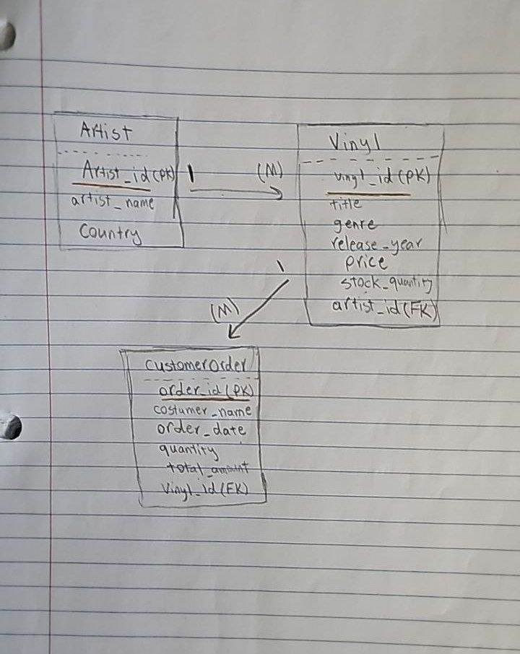

GITHUB LINK:
https://github.com/Albiiii7878/Databases-final-project
BIBLIOGRAPHY:
SQLite Documentation. SQLite Official Website. https://www.sqlite.org/docs.html
Oracle. JDBC Basics. https://docs.oracle.com/javase/tutorial/jdbc/

